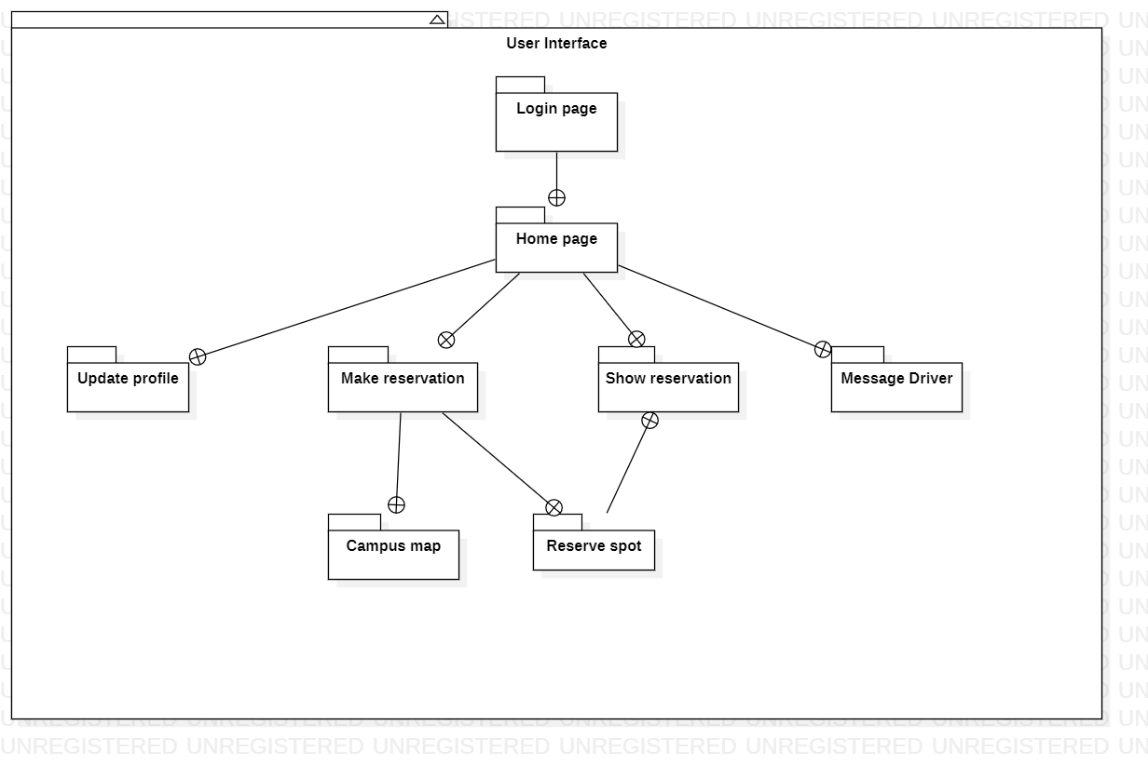This homework consists of three parts, namely, design, project plan, and coding convention.

- Design. The template for design is given (see the following pages).
  - You can find explanations regarding each section in the template
  - The UML tool is required to use. Rational Rose/Architect is available at the public lab.
    - We are almost done with the design, what we need to do now is assign pieces to people to complete.
      - This will be used to create the project plan.
- Project plan. Microsoft Project is required to use for the project plan.
  - We need to put everything into Microsoft Project.
- Coding Convention. You can choose to compose your own coding convention or use existing coding convention (e.g., Sun has coding convention for Java). No matter which way you go, please submit your coding convention document together with the design document.
  - Coding convention is not merely a document. You should stick to it. At the end of this semester, there will be a student peer code-review session. Keep in mind that all the assignments in this semester are competition-based. The teams will be ranked according their performance. The best team will receive the best grade.
  - We need to
  - The student peer code-review questions are given. Hence, when you start to write code, you know what will be evaluated.

Tasks

Scale for workload = 1 – 10(10 is longest time)
- Project Management, (Scale = 2)
- Testing (Scale = 3)
  - Austin
- System Development (Scale = 13)
  - GUI Development (Scale = 5)
    - Richu
  - Core system development (classes/implementation/facade) (Scale = 3)
  - Database and data layer (Scale = 2)
  - Adapters and external subsystem configuration (Scale = 3)
- Coding Conventions (Scale = 1)
  - Cut and paste/edit Google’s C++ coding convention document
- System Design (Total Scale = 10, Completed = 6)
  - Completed-(Scale = 6)
  - GUI Design- (Scale = 2)
  - Data Layer – (Scale = 2)
- Deployment target (Scale = 3)

Work Breakdown
- GUI Design and Development - Richu (Scale = 6)
- Core System Development, Coding Conventions – Leif (Scale = 4)
- Database and data layer, deployment target – Curt (Scale = 5)
- Testing, GUI Development – Austin (Scale = 4)
Total Scale = 19

Appendix
Project management (gant chart) (C)
Coding conventions (A)
GUI (B)
ER diagram (D)

Work breakdown for document
Section | Who
1 | TBD
7 | TBD
6 | Richu
5 | Austin
4 | Curt
3 | All
2 | Leif

Template
Software Design Specification
Version 1.0

Revisions
Version | Primary Author(s) | Description of Version | Date Completed
Contents
1 Introduction 1
1.1 System Overview 1
1.2 Supporting Materials 1
1.3 Definitions and Acronyms 1
2 Design Considerations 2
2.1 Assumptions 2
2.2 Constraints 2
2.3 Goals and Guidelines 2
3 Architecture 3
3.1 Overview 3
3.2 Strategies 3
3.2.1 Technical Environment 3
3.2.2 Maintainability 3
3.2.3 Performance 3
3.3 Software Specification 3
3.4 Hardware Specification 3
4 System Level Design 5
4.1 Hierarchy Chart Of Components 5
4.2 Sequence Diagrams And Descriptions 5
5 Object Level Design 6
5.1 Component C1 6
5.1.1 Class D1 Of Component C1 6
5.2 Component C2 6
6 User Interface Design 7
6.1 User Interface Design Overview 7
6.2 User Interface Navigation Hierarchy 7
7 Requirements Traceability Matrix 8
8 Appendices 9

Introduction
<Provide an overview of the entire document, including the purpose, the scope and the intended audience of the document. Identify the product using any applicable names and/or version numbers.>

System Overview

<Provide a general description of the software product including its functionality and matters related to the overall system and its design.>

Supporting Materials
<Provide references for any other pertinent documents such as related and/or companion documents, prerequisite documents and documents which provide background and/or context for this document.>

Definitions and Acronyms
<Define any important terms, acronyms, or abbreviations.>
Term | Description
SOA | Service Oriented Architecture
DFD | Data Flow Diagram

Design Considerations

Assumptions
<Describe any assumptions or dependencies regarding the software and its use. These may concern such issues as related software or hardware, operating systems, end-user characteristics, and possible and/or probable changes in functionality.>

Constraints
<Describe any global limitations or constraints that have a significant impact on the design of the system's software. Such constraints may be imposed by any of the following (the list is not exhaustive): hardware or software environment, end-user environment, availability or volatility of resources, standards compliance, interoperability requirements, interface/protocol requirements, data repository and distribution requirements, security requirements (or other such regulations), memory and other capacity limitations, performance requirements, network communications, and other requirements described in the requirements specification.>

Goals and Guidelines
<Describe any goals, guidelines, principles, or priorities which dominate or embody the design of the system's software. Such goals might be: the KISS principle ("Keep it simple stupid!"), emphasis on speed versus memory use, or working, looking, or "feeling" like an existing product. For each such goal or guideline, unless it is implicitly obvious, describe the reason for its desirability.>

Architecture

Overview
< Determine what parts of the application software will be assigned to what hardware. Describe any design decisions and/or strategies that affect the overall organization of the system and its higher-level structures. These strategies should provide insight into the key abstractions and mechanisms used in the system architecture. Describe the reasoning em-ployed for each decision and/or strategy (possibly referring to previously stated design goals and principles) and how any design goals or priorities were balanced or traded-off.>
Client server

Strategies

Technical Environment
<Special hardware, software, and network requirements imposed by business requirements>

Maintainability
<Expected business changes to which the system should be able to adapt>
Scalability,

Performance
<The time within which the system must perform its functions; the total and peak number of users and volume of data expected; the extent to which the system will be available to the users and the permissible failure rate due to errors>
Default timeout for web request

Software Specification
<Determine software needs, such as OS, development IDE, JDK version, other SDK version, etc. >

Hardware Specification
<
- Clients
  - Input/output devices employed by users
  - PCs, laptops, handheld devices, cell phones
- Servers
  - Larger computers storing software
  - Accessible by many users
- Network
  - Connects clients and servers>

System Level Design
<Provide a high-level overview of how the functionality and responsibilities of the system were partitioned and then assigned to subsystems or components. Don't go into too much detail about the individual components themselves (there is a subsequent section for detailed component descriptions). The main purpose here is to gain a general understanding of how and why the system was decomposed, and how the individual parts work together to provide the desired functionality.>

Hierarchy Chart Of Components
<Describe the major responsibilities that the software must undertake and the various roles that the system (or portions of the system) must play. Describe how the system was broken down into its components/subsystems (identifying each top-level component/subsystem and the roles/responsibilities assigned to it). Describe how the higher-level components collaborate with each other in order to achieve the required results. Don't forget to provide some sort of rationale for choosing this particular decomposition of the system (perhaps discussing other proposed decompositions and why they were rejected). >

Sequence Diagrams And Descriptions
<Describe the interaction behavior between classes. The typical sequence diagram will depict some or all of the behavior described in a use case. Therefore, sequence diagrams serve as an intermediary between use cases and classes. As a result, classes can be traced back to the requirements. >

Object Level Design
<Provide more detailed discussion in a subsection/component of the component hierarchy section 4.1. If necessary, describe how the component was further divided into subcomponents, and the relationships and interactions between the subcomponents (similar to what was done for top-level components in Section 4.1).>

Component C1
<Provide and describe a class hierarchy diagram that depicts the set of classes for Compo-nent C1>

Class D1 Of Component C1
<Provide a class diagram for Class D1 of Component C1. Provide a description of any relevant characteristics of Class D1.>

Component C2

User Interface Design

User Interface Design Overview
<Provide a high-level description of the user interface for this software application. Describe any systems requirements (e.g., performance or usability) associated with all of the user interfaces. >
A client-server-based software must have a user interface. Therefore, it is one of the main elements in any software system. This system is no different. The presentation layer of the system utilizes HTML5/CSS3 as the GUI and JavaScript and as it’s presentation logic. The interface contains of a series of responsive pages that the user can interact. Initially, the user will be taken to a login screen where the user can enter their credentials to login. Once successfully logged in, the user will be directed to the home page/landing page where there are four options. Those options include: update user’s password, view available spaces, view their reservation, and message driver. Note that the purpose of message driver is that it will notify the driver who have taken a spot reserved for another driver. Also, to prevent aggressive communication between drivers, the system will automatically generate messages.
The interface will run on any common OS independent web browsers such as chrome and fire fox. Depending on network speed, the web pages should load within the default time of a web requests.

User Interface Navigation Hierarchy
<Provide and describe a diagram of the navigation hierarchy that illustrates how a user moves through the user interface.>
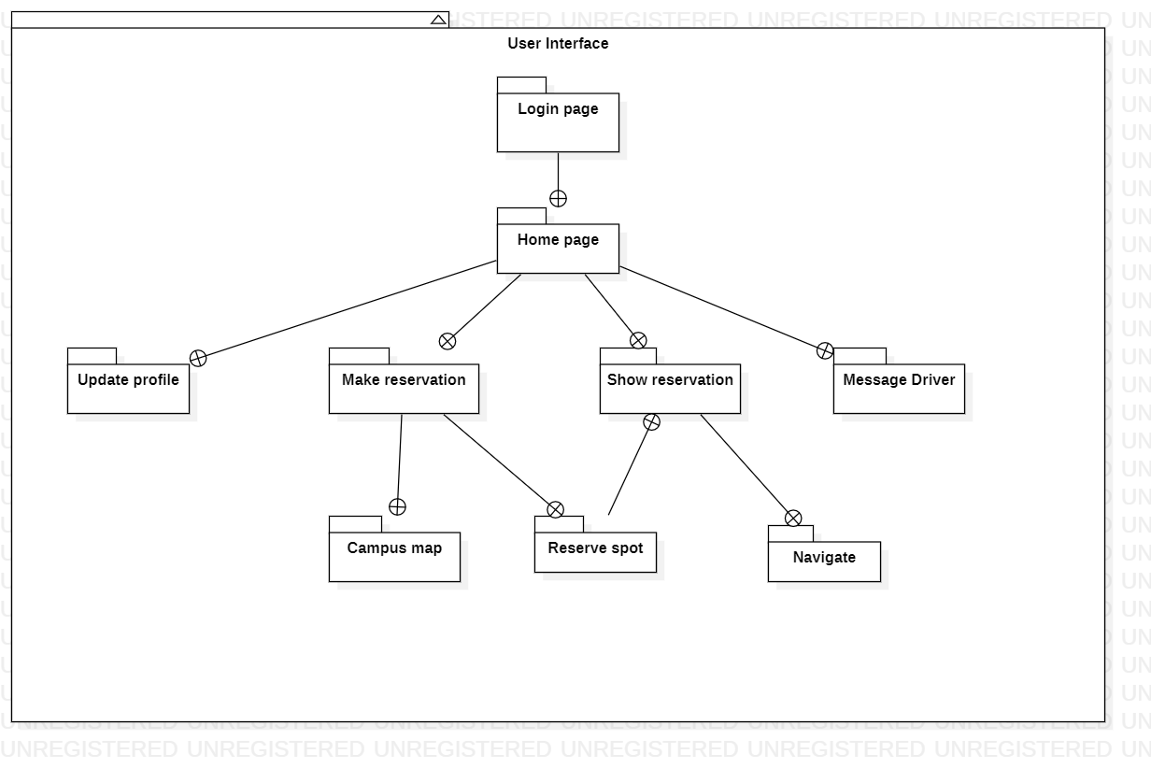
The package diagram above represents the navigation path of the user interface. Initially, when the user login, the page directs to the home page. In the home page, the user has four options, they are update profile, make reservation, show reservation, and message driver. The make reservation page has two GUI, campus map and reserve spot. By clicking “Reserve” in make reservation page, the user will be taken to show reservation page. The user can also reach the show reservation page by clicking “My reservation” button from the home page. The show reservation page allows the user “Navigate” to their reserved spot and mark that spot as “Occupy”, “Leave” or “Cancel”.

User Interfaces System Requirements

Login

The application starts with the login page (screen shot of login page can be seen in appendix B “picture 8.1.1.1”). The user will enter his/her user name for validation purposes and click the “LOGIN” button to proceed to the home page.

Requirements
The user does not have to enter their full UCO email extension. The text field already has the extension to its right. If the user does not exist in the system, the system will generate a temporary password and an email will be send to the user specified address.

Home page
After the user successfully login, the user will be taken to the home page (displayed in the appendix B “picture 8.1.1.2”). Here the user has four options to choose from.

Requirements
As mentioned in the requirements for login page, first time users will receive a temporary password via email. The user cannot experience the full capability of the system without resetting his/her password. Every button will be disabled except the “Update profile”. This is to make sure that the user has entered all the necessary information.

Update profile
The user can update their profile by clicking the Update profile button in the homepage. Here the user will be prompted for some inputs. (screen shot in appendix B “picture 8.1.1.3”)

Requirements

It is necessary to fill out all the fields in this page.

View available
This page allows the user to do the following actions:
- View campus map
Here the user can view the campus map by clicking “Campus map” button in the view available page. The user will be taken to a page owned by UCO, which displays an image of the entire campus in .pdf format (Reference can be found under section 8.1.2 appendix B “ref 8.1.2.1”).
- Make reservation
Here the user can reserve their spot by clicking “Reserve spot” button.

Requirements:
The user must select a lot from the dropdown next to “Reserve spot” button. Otherwise, a spot won’t be reserved, and nothing will be saved to the database.
Note: - Screenshot of this page can be seen in appendix B “picture 8.1.1.4”.

Show reservation
Once the user clicks the “Reserve spot button in View available page”, they will be directed to the show reservation page. Here the user can navigate to the spot by clicking “Navigate” which will open google maps in another page with the specified location. After the use has reached their destination the user can mark the spot as “Occupy”. When the user decides to leave, he/she can click “Leave” button to free that spot. Also, if the user decided to change his/her mind and want to cancel the reservation, they can do that by clicking “Cancel” button. (Screenshot in appendix B “picture 8.1.1.5”)
If the user wishes to go to the “Show reservation” directly from the home page, the user can do that by clicking “My reservation” button in the “Home page”. (appendix B “picture 8.1.1.2)

Requirements
This page uses Google maps API version 3.36 or above. (Reference: “ref 8.1.2.2”)

Message Driver
The system has a capability to message another, who is parked in someone else’s spot. The user can do this by clicking “Message driver” button in the home page. Here the user will select the vehicle’s registration state from a dropdown and enter the registration number. The system will generate a message and send it to the driver. (Screenshot in appendix B “picture 8.1.1.6”)

Requirements
In order to message a driver that driver must exist in the database.

Requirements Traceability Matrix
<Provide reference to the location of the Requirements Traceability Matrix that indicates traceability from the software requirements document to the design elements documented.>

Appendices
.

Appendix B
This appendix is provided to resources and references used in section 6 of this document. Section 6 consists of the user interface design and a package diagram representing the navigation path of the system.
Abbreviations | Acronyms
GUI | Graphical User Interface
API | Application Program Interface
OS | Operating System

Screenshots

picture 8.1.1.1

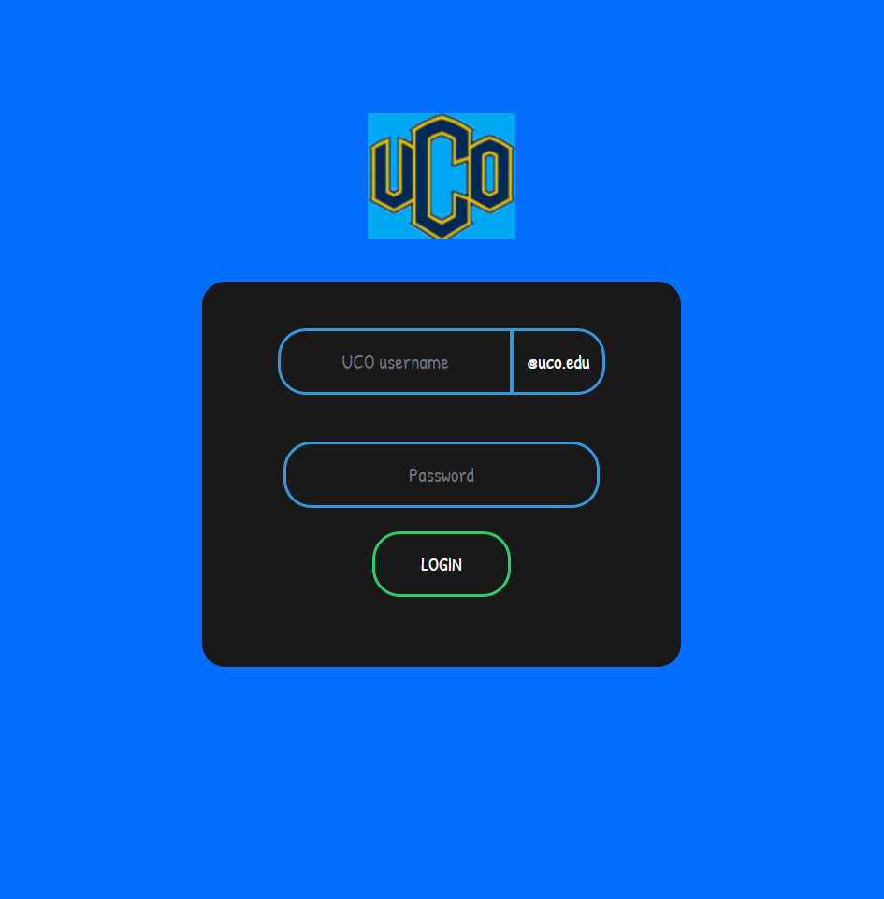

picture 8.1.1.2

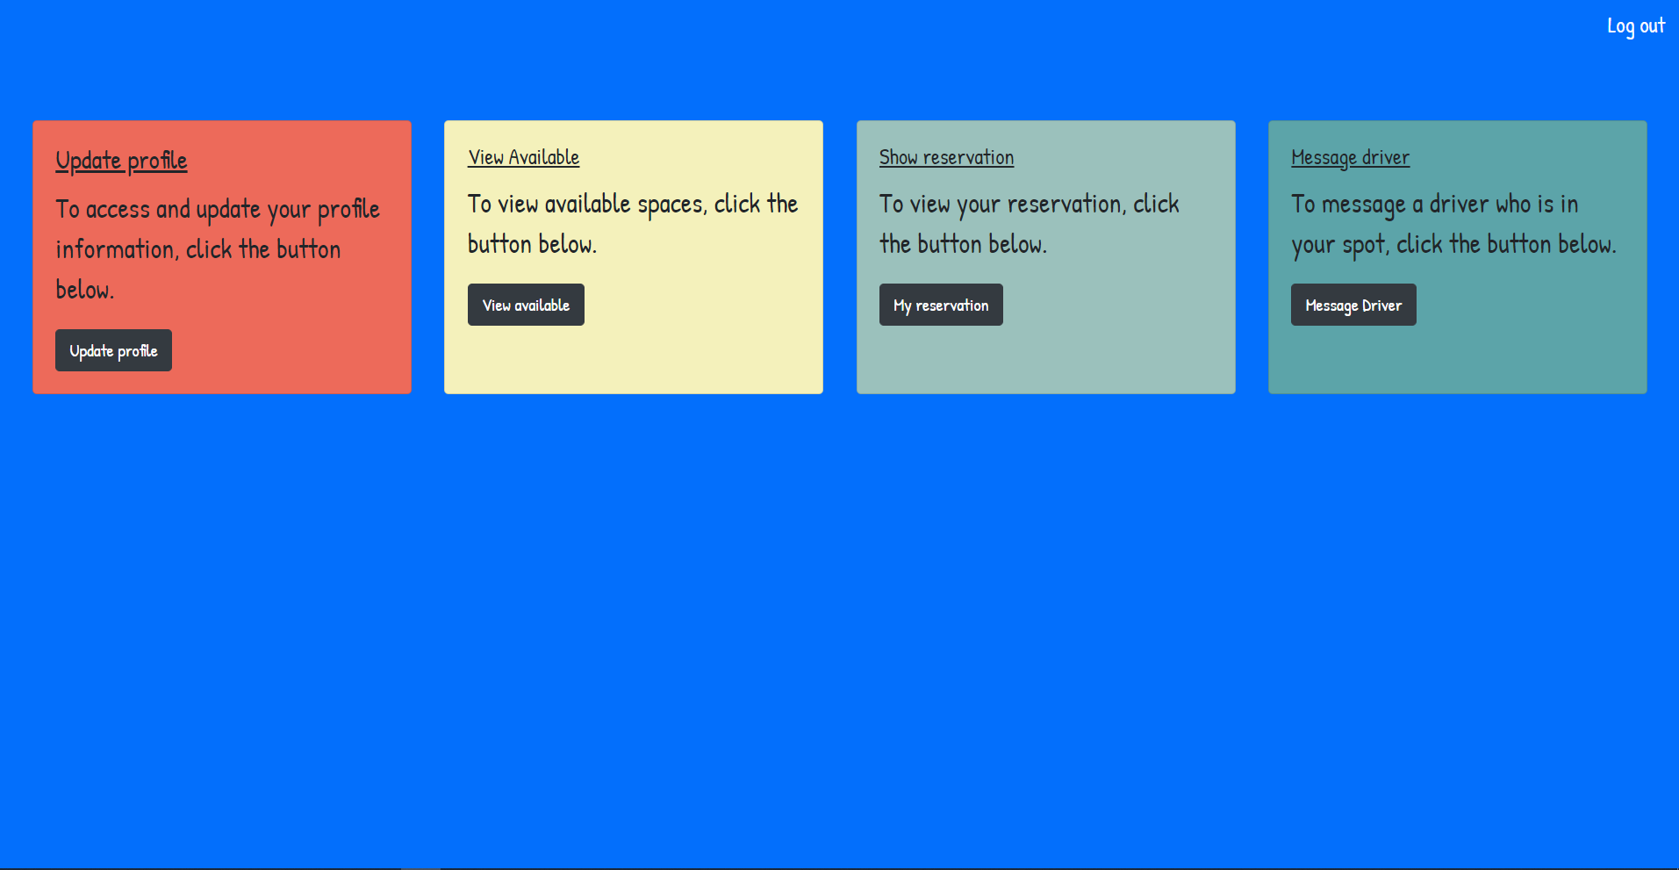

picture 8.1.1.3

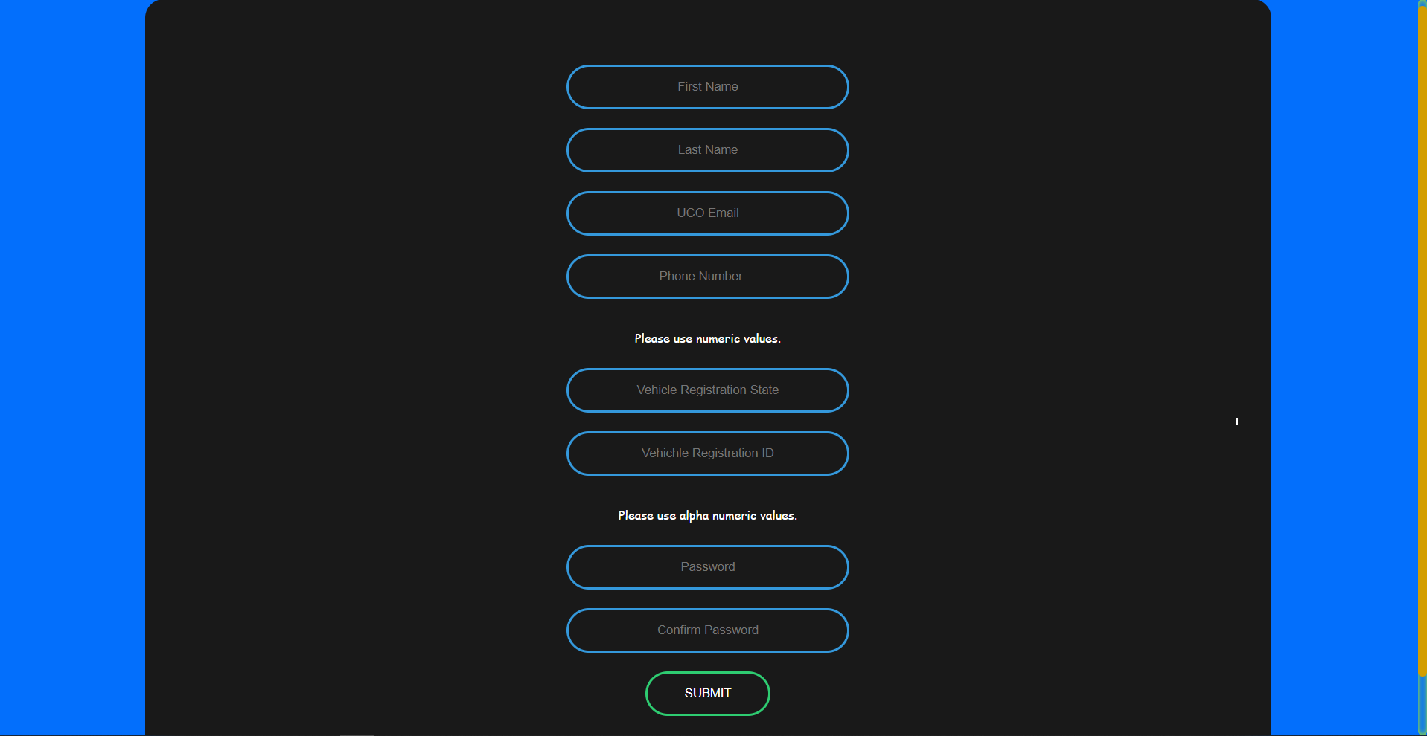

picture 8.1.1.4

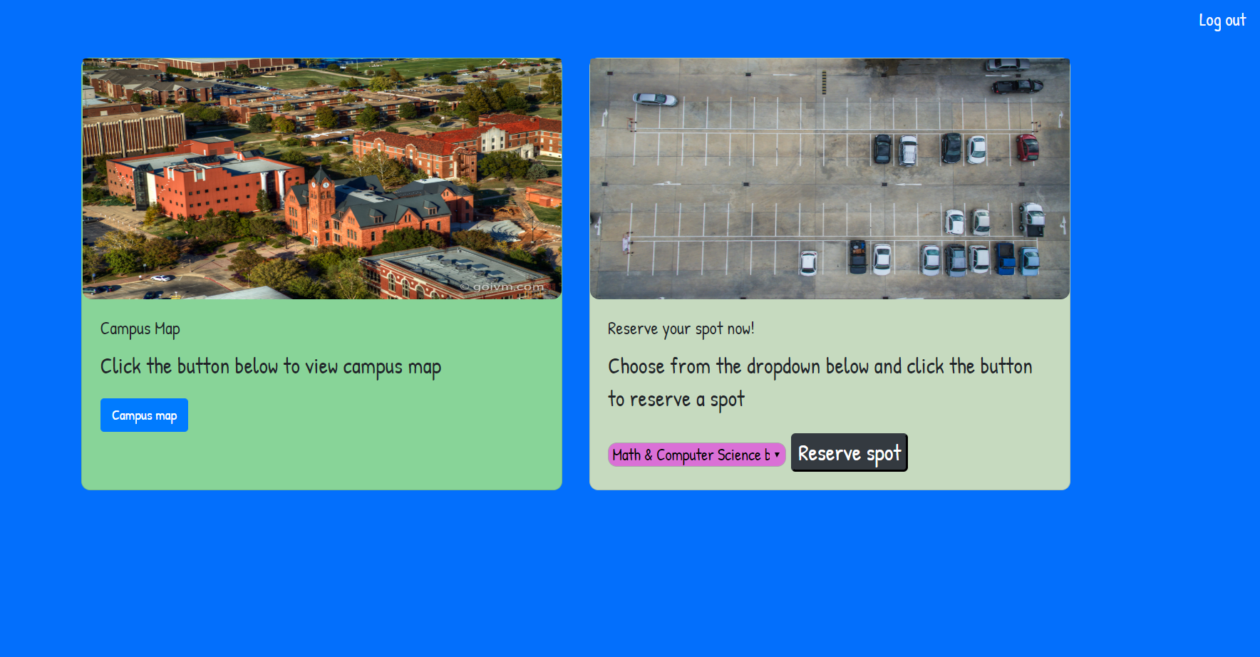

picture 8.1.1.5

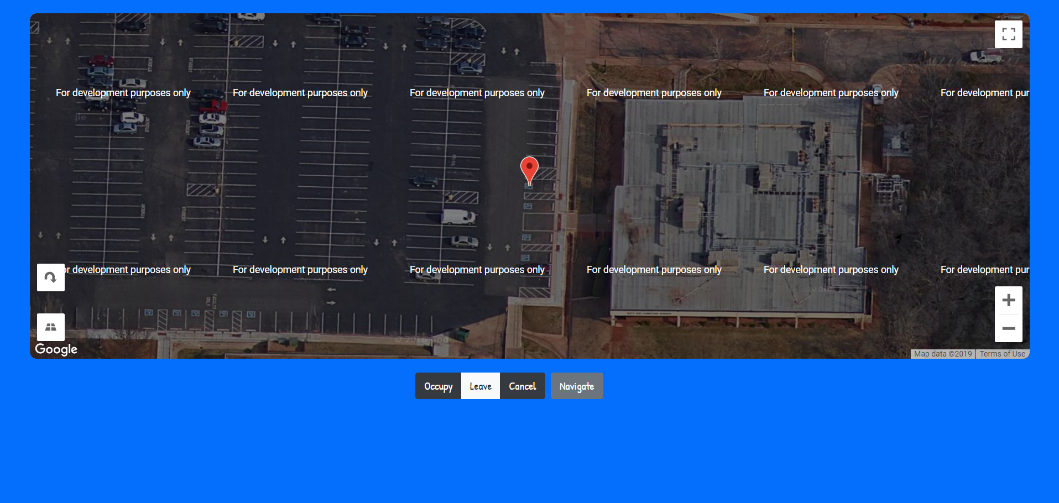

picture 8.1.1.6

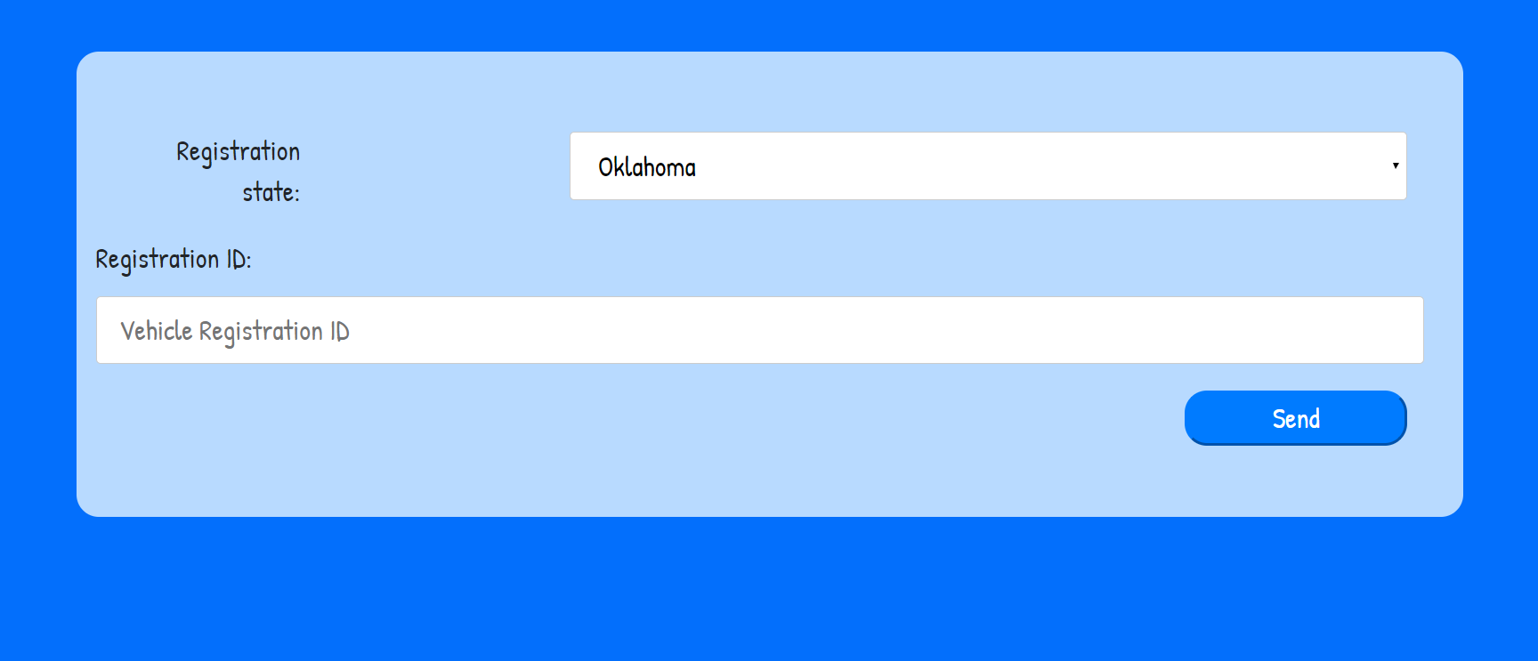

References

ref 8.1.2.1
Campus map link:
https://www.uco.edu/files/maps/uco-parking-map.pdf

ref 8.1.2.2
Google maps API:
https://cloud.google.com/maps-platform/

